- Sign in: (Anas Khaleel TP057388)
Form1

Form1
Picturebox1

Picturebox1

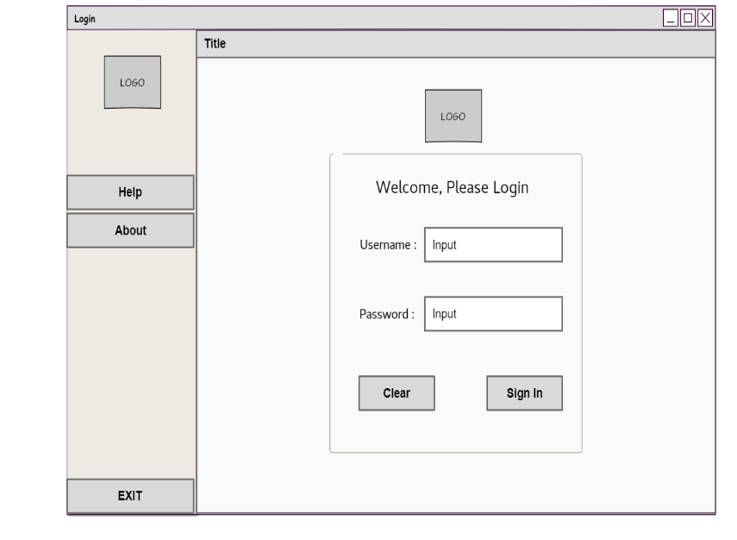
Picturebox1
button1
button2
button3

Control | Control name | Description
Form1 | SingIn | Webform responsible for singing in
Label1 | lblLogin | To act as header
Label2 | lblUsername | To label the related controls to the right
Label3 | lblPassword
Picturebox1 | Picturebox1 | To insert ad the logo picture
Picturebox1(Form1) | Picturebox1
Textbox1 | txtUsername | To accept text values form the user
Textbox2 | txtPassword
Button1 | btnHelp | Display a message box that contains contact mehtods
Button2 | btnAbout | Display a message box that contains an app description
Button3 | btnEXIT | Exit the application
Button1(Form1) | btnSignIn | Responsible for initializing code
Button2(Form1) | btnClear | Clear the text fields
Panel1 | panelSideMenu | Act as a side menu
button3
Label2

Label2
Label3

Label3
Label1

Label1
Textbox1
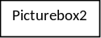

Textbox1
Textbox2

Textbox2

button1

button1
button2

button2
Panel1

Panel1
Sign in
Control | Control name | Description
Form1 | SingIn | Responsible for singing in
Label1 | lblLogin | To act as header
Label2 | lblUsername | To label the related controls to the right
Label3 | lblPassword
Picturebox1 | Picturebox1 | To insert ad the logo picture
Picturebox1(Form1) | Picturebox1
Textbox1 | txtUsername | To accept text values form the user
Textbox2 | txtPassword
Button1 | btnHelp | Display a message box that contains contact methods
Button2 | btnAbout | Display a message box that contains an app description
Button3 | btnEXIT | Exit the application
Button1(Form1) | btnSignIn | Responsible for initializing code
Button2(Form1) | btnClear | Clear the text fields
Panel1 | panelSideMenu | Act as a side menu
Panel2

Control | Control name | Description
Form1 | SingIn | Webform responsible for singing in
Label1 | lblLogin | To act as header
Label2 | lblUsername | To label the related controls to the right
Label3 | lblPassword
Picturebox1 | Picturebox1 | To insert ad the logo picture
Picturebox1(Form1) | Picturebox1
Textbox1 | txtUsername | To accept text values form the user
Textbox2 | txtPassword
Button1 | btnHelp | Display a message box that contains contact mehtods
Button2 | btnAbout | Display a message box that contains an app description
Button3 | btnEXIT | Exit the application
Button1(Form1) | btnSignIn | Responsible for initializing code
Button2(Form1) | btnClear | Clear the text fields
Panel1 | panelSideMenu | Act as a side menu
button3
2-Administrator view:
Form2

Control | Control name | Description
Form1 | SingIn | Webform responsible for singing in
Label1 | lblLogin | To act as header
Label2 | lblUsername | To label the related controls to the right
Label3 | lblPassword
Picturebox1 | Picturebox1 | To insert ad the logo picture
Picturebox1(Form1) | Picturebox1
Textbox1 | txtUsername | To accept text values form the user
Textbox2 | txtPassword
Button1 | btnHelp | Display a message box that contains contact mehtods
Button2 | btnAbout | Display a message box that contains an app description
Button3 | btnEXIT | Exit the application
Button1(Form1) | btnSignIn | Responsible for initializing code
Button2(Form1) | btnClear | Clear the text fields
Panel1 | panelSideMenu | Act as a side menu
button3
Picturebox1

Control | Control name | Description
Form1 | SingIn | Webform responsible for singing in
Label1 | lblLogin | To act as header
Label2 | lblUsername | To label the related controls to the right
Label3 | lblPassword
Picturebox1 | Picturebox1 | To insert ad the logo picture
Picturebox1(Form1) | Picturebox1
Textbox1 | txtUsername | To accept text values form the user
Textbox2 | txtPassword
Button1 | btnHelp | Display a message box that contains contact mehtods
Button2 | btnAbout | Display a message box that contains an app description
Button3 | btnEXIT | Exit the application
Button1(Form1) | btnSignIn | Responsible for initializing code
Button2(Form1) | btnClear | Clear the text fields
Panel1 | panelSideMenu | Act as a side menu
button3
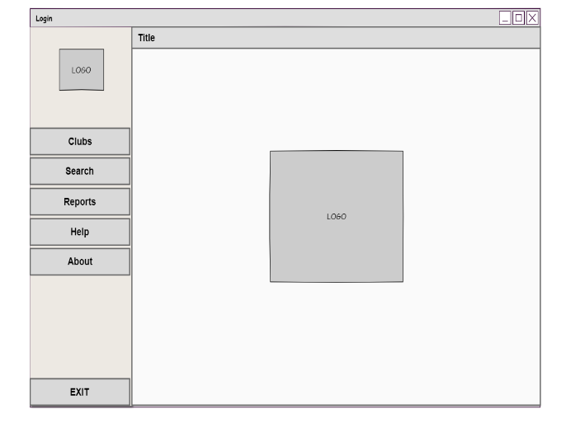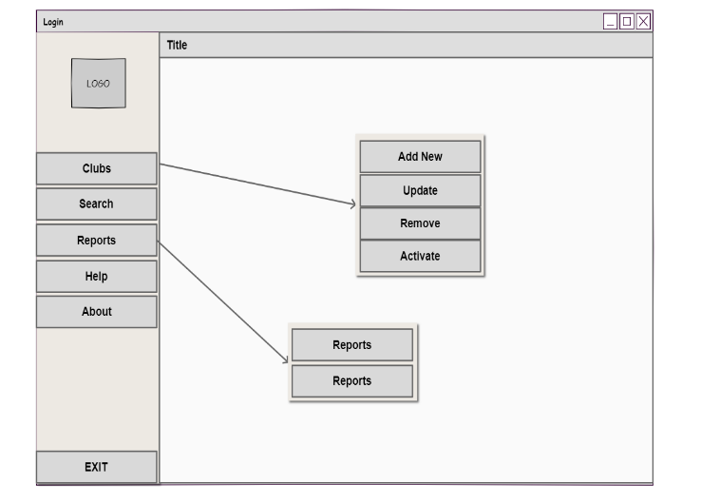
Button4

Control | Control name | Description
Form1 | SingIn | Webform responsible for singing in
Label1 | lblLogin | To act as header
Label2 | lblUsername | To label the related controls to the right
Label3 | lblPassword
Picturebox1 | Picturebox1 | To insert ad the logo picture
Picturebox1(Form1) | Picturebox1
Textbox1 | txtUsername | To accept text values form the user
Textbox2 | txtPassword
Button1 | btnHelp | Display a message box that contains contact mehtods
Button2 | btnAbout | Display a message box that contains an app description
Button3 | btnEXIT | Exit the application
Button1(Form1) | btnSignIn | Responsible for initializing code
Button2(Form1) | btnClear | Clear the text fields
Panel1 | panelSideMenu | Act as a side menu
button3
Button5

Control | Control name | Description
Form1 | SingIn | Webform responsible for singing in
Label1 | lblLogin | To act as header
Label2 | lblUsername | To label the related controls to the right
Label3 | lblPassword
Picturebox1 | Picturebox1 | To insert ad the logo picture
Picturebox1(Form1) | Picturebox1
Textbox1 | txtUsername | To accept text values form the user
Textbox2 | txtPassword
Button1 | btnHelp | Display a message box that contains contact mehtods
Button2 | btnAbout | Display a message box that contains an app description
Button3 | btnEXIT | Exit the application
Button1(Form1) | btnSignIn | Responsible for initializing code
Button2(Form1) | btnClear | Clear the text fields
Panel1 | panelSideMenu | Act as a side menu
button3
Button6

Control | Control name | Description
Form1 | SingIn | Webform responsible for singing in
Label1 | lblLogin | To act as header
Label2 | lblUsername | To label the related controls to the right
Label3 | lblPassword
Picturebox1 | Picturebox1 | To insert ad the logo picture
Picturebox1(Form1) | Picturebox1
Textbox1 | txtUsername | To accept text values form the user
Textbox2 | txtPassword
Button1 | btnHelp | Display a message box that contains contact mehtods
Button2 | btnAbout | Display a message box that contains an app description
Button3 | btnEXIT | Exit the application
Button1(Form1) | btnSignIn | Responsible for initializing code
Button2(Form1) | btnClear | Clear the text fields
Panel1 | panelSideMenu | Act as a side menu
button3
Button12

Control | Control name | Description
Form1 | SingIn | Webform responsible for singing in
Label1 | lblLogin | To act as header
Label2 | lblUsername | To label the related controls to the right
Label3 | lblPassword
Picturebox1 | Picturebox1 | To insert ad the logo picture
Picturebox1(Form1) | Picturebox1
Textbox1 | txtUsername | To accept text values form the user
Textbox2 | txtPassword
Button1 | btnHelp | Display a message box that contains contact mehtods
Button2 | btnAbout | Display a message box that contains an app description
Button3 | btnEXIT | Exit the application
Button1(Form1) | btnSignIn | Responsible for initializing code
Button2(Form1) | btnClear | Clear the text fields
Panel1 | panelSideMenu | Act as a side menu
button3
Button11

Control | Control name | Description
Form1 | SingIn | Webform responsible for singing in
Label1 | lblLogin | To act as header
Label2 | lblUsername | To label the related controls to the right
Label3 | lblPassword
Picturebox1 | Picturebox1 | To insert ad the logo picture
Picturebox1(Form1) | Picturebox1
Textbox1 | txtUsername | To accept text values form the user
Textbox2 | txtPassword
Button1 | btnHelp | Display a message box that contains contact mehtods
Button2 | btnAbout | Display a message box that contains an app description
Button3 | btnEXIT | Exit the application
Button1(Form1) | btnSignIn | Responsible for initializing code
Button2(Form1) | btnClear | Clear the text fields
Panel1 | panelSideMenu | Act as a side menu
button3
Button10

Control | Control name | Description
Form1 | SingIn | Webform responsible for singing in
Label1 | lblLogin | To act as header
Label2 | lblUsername | To label the related controls to the right
Label3 | lblPassword
Picturebox1 | Picturebox1 | To insert ad the logo picture
Picturebox1(Form1) | Picturebox1
Textbox1 | txtUsername | To accept text values form the user
Textbox2 | txtPassword
Button1 | btnHelp | Display a message box that contains contact mehtods
Button2 | btnAbout | Display a message box that contains an app description
Button3 | btnEXIT | Exit the application
Button1(Form1) | btnSignIn | Responsible for initializing code
Button2(Form1) | btnClear | Clear the text fields
Panel1 | panelSideMenu | Act as a side menu
button3
Button9

Control | Control name | Description
Form1 | SingIn | Webform responsible for singing in
Label1 | lblLogin | To act as header
Label2 | lblUsername | To label the related controls to the right
Label3 | lblPassword
Picturebox1 | Picturebox1 | To insert ad the logo picture
Picturebox1(Form1) | Picturebox1
Textbox1 | txtUsername | To accept text values form the user
Textbox2 | txtPassword
Button1 | btnHelp | Display a message box that contains contact mehtods
Button2 | btnAbout | Display a message box that contains an app description
Button3 | btnEXIT | Exit the application
Button1(Form1) | btnSignIn | Responsible for initializing code
Button2(Form1) | btnClear | Clear the text fields
Panel1 | panelSideMenu | Act as a side menu
button3
Button8

Control | Control name | Description
Form1 | SingIn | Webform responsible for singing in
Label1 | lblLogin | To act as header
Label2 | lblUsername | To label the related controls to the right
Label3 | lblPassword
Picturebox1 | Picturebox1 | To insert ad the logo picture
Picturebox1(Form1) | Picturebox1
Textbox1 | txtUsername | To accept text values form the user
Textbox2 | txtPassword
Button1 | btnHelp | Display a message box that contains contact mehtods
Button2 | btnAbout | Display a message box that contains an app description
Button3 | btnEXIT | Exit the application
Button1(Form1) | btnSignIn | Responsible for initializing code
Button2(Form1) | btnClear | Clear the text fields
Panel1 | panelSideMenu | Act as a side menu
button3
Button7

Control | Control name | Description
Form1 | SingIn | Webform responsible for singing in
Label1 | lblLogin | To act as header
Label2 | lblUsername | To label the related controls to the right
Label3 | lblPassword
Picturebox1 | Picturebox1 | To insert ad the logo picture
Picturebox1(Form1) | Picturebox1
Textbox1 | txtUsername | To accept text values form the user
Textbox2 | txtPassword
Button1 | btnHelp | Display a message box that contains contact mehtods
Button2 | btnAbout | Display a message box that contains an app description
Button3 | btnEXIT | Exit the application
Button1(Form1) | btnSignIn | Responsible for initializing code
Button2(Form1) | btnClear | Clear the text fields
Panel1 | panelSideMenu | Act as a side menu
button3
Panel3

Control | Control name | Description
Form1 | SingIn | Webform responsible for singing in
Label1 | lblLogin | To act as header
Label2 | lblUsername | To label the related controls to the right
Label3 | lblPassword
Picturebox1 | Picturebox1 | To insert ad the logo picture
Picturebox1(Form1) | Picturebox1
Textbox1 | txtUsername | To accept text values form the user
Textbox2 | txtPassword
Button1 | btnHelp | Display a message box that contains contact mehtods
Button2 | btnAbout | Display a message box that contains an app description
Button3 | btnEXIT | Exit the application
Button1(Form1) | btnSignIn | Responsible for initializing code
Button2(Form1) | btnClear | Clear the text fields
Panel1 | panelSideMenu | Act as a side menu
button3
Control | Control Name | Description
Form2 | Logo | Forn the displays logo after signing in
Button4 | btnClubs | Responsible for the visibility of a panel called “panelClubsSubMenu”
Button5 | btnSearch | Opens a form called “Search”
Button6 | btnReports | Responsible for the visibility of a panel called “panelReportsSubMenu”
Button7 | btnAddNew | Opens a form called “AddNew”
Button8 | btnUpdate | Opens a form called “Update”
Button9 | btnRemove | Opens a form called “Remove”
Button10 | btnActivate | Opens a form called “Activate”
Button11 | btnListReports | Opens a form called “ListReports”
Button12 | btnClubActivity | Opens a form called “Activity”
Panel2 | panelClubsSubMenu | Act as a sub menu
Panel3 | panelReportsSubMenu | Act as a sub menu

Administrator Forms Access :
1-Admin view(Clubs-Add new) : 2-Admin view(Clubs-Update):
Label1

Control | Control name | Description
Form1 | SingIn | Webform responsible for singing in
Label1 | lblLogin | To act as header
Label2 | lblUsername | To label the related controls to the right
Label3 | lblPassword
Picturebox1 | Picturebox1 | To insert ad the logo picture
Picturebox1(Form1) | Picturebox1
Textbox1 | txtUsername | To accept text values form the user
Textbox2 | txtPassword
Button1 | btnHelp | Display a message box that contains contact mehtods
Button2 | btnAbout | Display a message box that contains an app description
Button3 | btnEXIT | Exit the application
Button1(Form1) | btnSignIn | Responsible for initializing code
Button2(Form1) | btnClear | Clear the text fields
Panel1 | panelSideMenu | Act as a side menu
button3
Label2

Control | Control name | Description
Form1 | SingIn | Webform responsible for singing in
Label1 | lblLogin | To act as header
Label2 | lblUsername | To label the related controls to the right
Label3 | lblPassword
Picturebox1 | Picturebox1 | To insert ad the logo picture
Picturebox1(Form1) | Picturebox1
Textbox1 | txtUsername | To accept text values form the user
Textbox2 | txtPassword
Button1 | btnHelp | Display a message box that contains contact mehtods
Button2 | btnAbout | Display a message box that contains an app description
Button3 | btnEXIT | Exit the application
Button1(Form1) | btnSignIn | Responsible for initializing code
Button2(Form1) | btnClear | Clear the text fields
Panel1 | panelSideMenu | Act as a side menu
button3
Textbox1

Control | Control name | Description
Form1 | SingIn | Webform responsible for singing in
Label1 | lblLogin | To act as header
Label2 | lblUsername | To label the related controls to the right
Label3 | lblPassword
Picturebox1 | Picturebox1 | To insert ad the logo picture
Picturebox1(Form1) | Picturebox1
Textbox1 | txtUsername | To accept text values form the user
Textbox2 | txtPassword
Button1 | btnHelp | Display a message box that contains contact mehtods
Button2 | btnAbout | Display a message box that contains an app description
Button3 | btnEXIT | Exit the application
Button1(Form1) | btnSignIn | Responsible for initializing code
Button2(Form1) | btnClear | Clear the text fields
Panel1 | panelSideMenu | Act as a side menu
button3
Label1

Control | Control name | Description
Form1 | SingIn | Webform responsible for singing in
Label1 | lblLogin | To act as header
Label2 | lblUsername | To label the related controls to the right
Label3 | lblPassword
Picturebox1 | Picturebox1 | To insert ad the logo picture
Picturebox1(Form1) | Picturebox1
Textbox1 | txtUsername | To accept text values form the user
Textbox2 | txtPassword
Button1 | btnHelp | Display a message box that contains contact mehtods
Button2 | btnAbout | Display a message box that contains an app description
Button3 | btnEXIT | Exit the application
Button1(Form1) | btnSignIn | Responsible for initializing code
Button2(Form1) | btnClear | Clear the text fields
Panel1 | panelSideMenu | Act as a side menu
button3
Label3

Control | Control name | Description
Form1 | SingIn | Webform responsible for singing in
Label1 | lblLogin | To act as header
Label2 | lblUsername | To label the related controls to the right
Label3 | lblPassword
Picturebox1 | Picturebox1 | To insert ad the logo picture
Picturebox1(Form1) | Picturebox1
Textbox1 | txtUsername | To accept text values form the user
Textbox2 | txtPassword
Button1 | btnHelp | Display a message box that contains contact mehtods
Button2 | btnAbout | Display a message box that contains an app description
Button3 | btnEXIT | Exit the application
Button1(Form1) | btnSignIn | Responsible for initializing code
Button2(Form1) | btnClear | Clear the text fields
Panel1 | panelSideMenu | Act as a side menu
button3
Combobox1

Control | Control name | Description
Form1 | SingIn | Webform responsible for singing in
Label1 | lblLogin | To act as header
Label2 | lblUsername | To label the related controls to the right
Label3 | lblPassword
Picturebox1 | Picturebox1 | To insert ad the logo picture
Picturebox1(Form1) | Picturebox1
Textbox1 | txtUsername | To accept text values form the user
Textbox2 | txtPassword
Button1 | btnHelp | Display a message box that contains contact mehtods
Button2 | btnAbout | Display a message box that contains an app description
Button3 | btnEXIT | Exit the application
Button1(Form1) | btnSignIn | Responsible for initializing code
Button2(Form1) | btnClear | Clear the text fields
Panel1 | panelSideMenu | Act as a side menu
button3
Label2

Control | Control name | Description
Form1 | SingIn | Webform responsible for singing in
Label1 | lblLogin | To act as header
Label2 | lblUsername | To label the related controls to the right
Label3 | lblPassword
Picturebox1 | Picturebox1 | To insert ad the logo picture
Picturebox1(Form1) | Picturebox1
Textbox1 | txtUsername | To accept text values form the user
Textbox2 | txtPassword
Button1 | btnHelp | Display a message box that contains contact mehtods
Button2 | btnAbout | Display a message box that contains an app description
Button3 | btnEXIT | Exit the application
Button1(Form1) | btnSignIn | Responsible for initializing code
Button2(Form1) | btnClear | Clear the text fields
Panel1 | panelSideMenu | Act as a side menu
button3
Form4

Control | Control name | Description
Form1 | SingIn | Webform responsible for singing in
Label1 | lblLogin | To act as header
Label2 | lblUsername | To label the related controls to the right
Label3 | lblPassword
Picturebox1 | Picturebox1 | To insert ad the logo picture
Picturebox1(Form1) | Picturebox1
Textbox1 | txtUsername | To accept text values form the user
Textbox2 | txtPassword
Button1 | btnHelp | Display a message box that contains contact mehtods
Button2 | btnAbout | Display a message box that contains an app description
Button3 | btnEXIT | Exit the application
Button1(Form1) | btnSignIn | Responsible for initializing code
Button2(Form1) | btnClear | Clear the text fields
Panel1 | panelSideMenu | Act as a side menu
button3
Textbox1

Control | Control name | Description
Form1 | SingIn | Webform responsible for singing in
Label1 | lblLogin | To act as header
Label2 | lblUsername | To label the related controls to the right
Label3 | lblPassword
Picturebox1 | Picturebox1 | To insert ad the logo picture
Picturebox1(Form1) | Picturebox1
Textbox1 | txtUsername | To accept text values form the user
Textbox2 | txtPassword
Button1 | btnHelp | Display a message box that contains contact mehtods
Button2 | btnAbout | Display a message box that contains an app description
Button3 | btnEXIT | Exit the application
Button1(Form1) | btnSignIn | Responsible for initializing code
Button2(Form1) | btnClear | Clear the text fields
Panel1 | panelSideMenu | Act as a side menu
button3
Form3

Control | Control name | Description
Form1 | SingIn | Webform responsible for singing in
Label1 | lblLogin | To act as header
Label2 | lblUsername | To label the related controls to the right
Label3 | lblPassword
Picturebox1 | Picturebox1 | To insert ad the logo picture
Picturebox1(Form1) | Picturebox1
Textbox1 | txtUsername | To accept text values form the user
Textbox2 | txtPassword
Button1 | btnHelp | Display a message box that contains contact mehtods
Button2 | btnAbout | Display a message box that contains an app description
Button3 | btnEXIT | Exit the application
Button1(Form1) | btnSignIn | Responsible for initializing code
Button2(Form1) | btnClear | Clear the text fields
Panel1 | panelSideMenu | Act as a side menu
button3
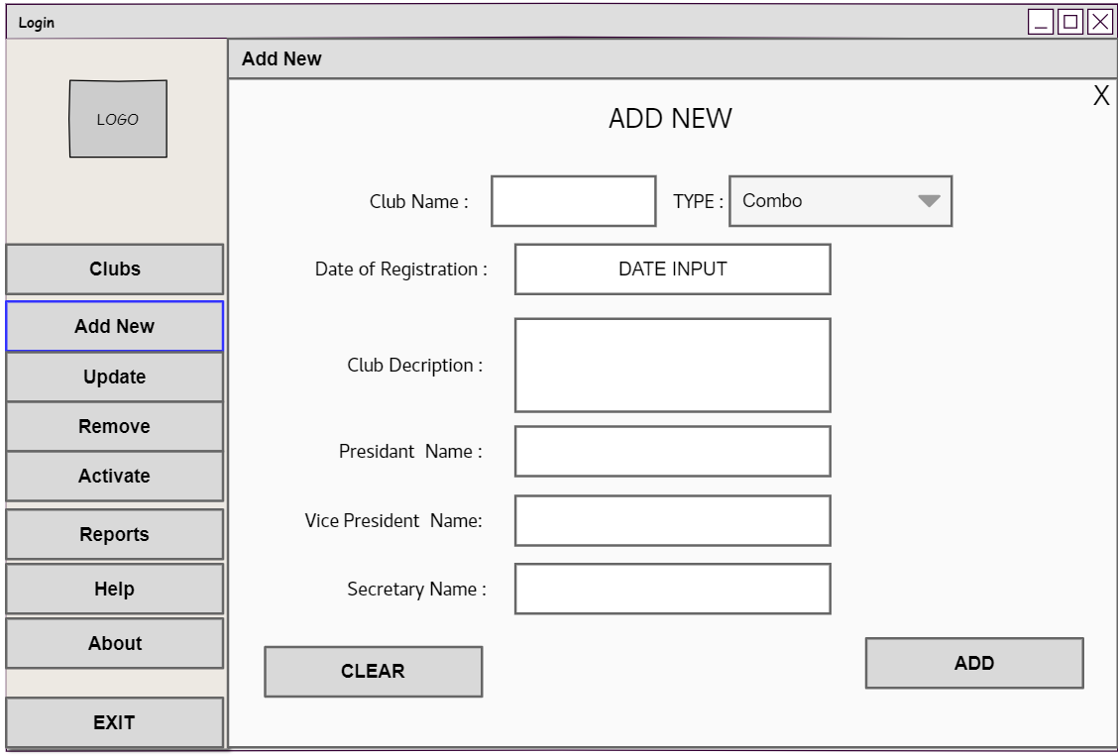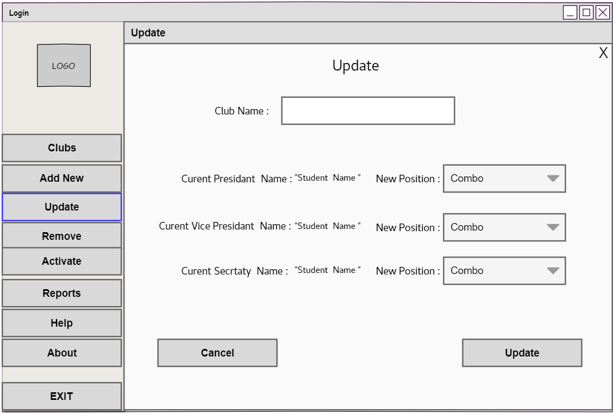
Combobox1

Control | Control name | Description
Form1 | SingIn | Webform responsible for singing in
Label1 | lblLogin | To act as header
Label2 | lblUsername | To label the related controls to the right
Label3 | lblPassword
Picturebox1 | Picturebox1 | To insert ad the logo picture
Picturebox1(Form1) | Picturebox1
Textbox1 | txtUsername | To accept text values form the user
Textbox2 | txtPassword
Button1 | btnHelp | Display a message box that contains contact mehtods
Button2 | btnAbout | Display a message box that contains an app description
Button3 | btnEXIT | Exit the application
Button1(Form1) | btnSignIn | Responsible for initializing code
Button2(Form1) | btnClear | Clear the text fields
Panel1 | panelSideMenu | Act as a side menu
button3
Combobox2

Control | Control name | Description
Form1 | SingIn | Webform responsible for singing in
Label1 | lblLogin | To act as header
Label2 | lblUsername | To label the related controls to the right
Label3 | lblPassword
Picturebox1 | Picturebox1 | To insert ad the logo picture
Picturebox1(Form1) | Picturebox1
Textbox1 | txtUsername | To accept text values form the user
Textbox2 | txtPassword
Button1 | btnHelp | Display a message box that contains contact mehtods
Button2 | btnAbout | Display a message box that contains an app description
Button3 | btnEXIT | Exit the application
Button1(Form1) | btnSignIn | Responsible for initializing code
Button2(Form1) | btnClear | Clear the text fields
Panel1 | panelSideMenu | Act as a side menu
button3
Combobox3

Control | Control name | Description
Form1 | SingIn | Webform responsible for singing in
Label1 | lblLogin | To act as header
Label2 | lblUsername | To label the related controls to the right
Label3 | lblPassword
Picturebox1 | Picturebox1 | To insert ad the logo picture
Picturebox1(Form1) | Picturebox1
Textbox1 | txtUsername | To accept text values form the user
Textbox2 | txtPassword
Button1 | btnHelp | Display a message box that contains contact mehtods
Button2 | btnAbout | Display a message box that contains an app description
Button3 | btnEXIT | Exit the application
Button1(Form1) | btnSignIn | Responsible for initializing code
Button2(Form1) | btnClear | Clear the text fields
Panel1 | panelSideMenu | Act as a side menu
button3
Label5

Control | Control name | Description
Form1 | SingIn | Webform responsible for singing in
Label1 | lblLogin | To act as header
Label2 | lblUsername | To label the related controls to the right
Label3 | lblPassword
Picturebox1 | Picturebox1 | To insert ad the logo picture
Picturebox1(Form1) | Picturebox1
Textbox1 | txtUsername | To accept text values form the user
Textbox2 | txtPassword
Button1 | btnHelp | Display a message box that contains contact mehtods
Button2 | btnAbout | Display a message box that contains an app description
Button3 | btnEXIT | Exit the application
Button1(Form1) | btnSignIn | Responsible for initializing code
Button2(Form1) | btnClear | Clear the text fields
Panel1 | panelSideMenu | Act as a side menu
button3
Label6

Control | Control name | Description
Form1 | SingIn | Webform responsible for singing in
Label1 | lblLogin | To act as header
Label2 | lblUsername | To label the related controls to the right
Label3 | lblPassword
Picturebox1 | Picturebox1 | To insert ad the logo picture
Picturebox1(Form1) | Picturebox1
Textbox1 | txtUsername | To accept text values form the user
Textbox2 | txtPassword
Button1 | btnHelp | Display a message box that contains contact mehtods
Button2 | btnAbout | Display a message box that contains an app description
Button3 | btnEXIT | Exit the application
Button1(Form1) | btnSignIn | Responsible for initializing code
Button2(Form1) | btnClear | Clear the text fields
Panel1 | panelSideMenu | Act as a side menu
button3
Label7

Control | Control name | Description
Form1 | SingIn | Webform responsible for singing in
Label1 | lblLogin | To act as header
Label2 | lblUsername | To label the related controls to the right
Label3 | lblPassword
Picturebox1 | Picturebox1 | To insert ad the logo picture
Picturebox1(Form1) | Picturebox1
Textbox1 | txtUsername | To accept text values form the user
Textbox2 | txtPassword
Button1 | btnHelp | Display a message box that contains contact mehtods
Button2 | btnAbout | Display a message box that contains an app description
Button3 | btnEXIT | Exit the application
Button1(Form1) | btnSignIn | Responsible for initializing code
Button2(Form1) | btnClear | Clear the text fields
Panel1 | panelSideMenu | Act as a side menu
button3
Label8

Control | Control name | Description
Form1 | SingIn | Webform responsible for singing in
Label1 | lblLogin | To act as header
Label2 | lblUsername | To label the related controls to the right
Label3 | lblPassword
Picturebox1 | Picturebox1 | To insert ad the logo picture
Picturebox1(Form1) | Picturebox1
Textbox1 | txtUsername | To accept text values form the user
Textbox2 | txtPassword
Button1 | btnHelp | Display a message box that contains contact mehtods
Button2 | btnAbout | Display a message box that contains an app description
Button3 | btnEXIT | Exit the application
Button1(Form1) | btnSignIn | Responsible for initializing code
Button2(Form1) | btnClear | Clear the text fields
Panel1 | panelSideMenu | Act as a side menu
button3
Label4

Control | Control name | Description
Form1 | SingIn | Webform responsible for singing in
Label1 | lblLogin | To act as header
Label2 | lblUsername | To label the related controls to the right
Label3 | lblPassword
Picturebox1 | Picturebox1 | To insert ad the logo picture
Picturebox1(Form1) | Picturebox1
Textbox1 | txtUsername | To accept text values form the user
Textbox2 | txtPassword
Button1 | btnHelp | Display a message box that contains contact mehtods
Button2 | btnAbout | Display a message box that contains an app description
Button3 | btnEXIT | Exit the application
Button1(Form1) | btnSignIn | Responsible for initializing code
Button2(Form1) | btnClear | Clear the text fields
Panel1 | panelSideMenu | Act as a side menu
button3
Textbox3

Control | Control name | Description
Form1 | SingIn | Webform responsible for singing in
Label1 | lblLogin | To act as header
Label2 | lblUsername | To label the related controls to the right
Label3 | lblPassword
Picturebox1 | Picturebox1 | To insert ad the logo picture
Picturebox1(Form1) | Picturebox1
Textbox1 | txtUsername | To accept text values form the user
Textbox2 | txtPassword
Button1 | btnHelp | Display a message box that contains contact mehtods
Button2 | btnAbout | Display a message box that contains an app description
Button3 | btnEXIT | Exit the application
Button1(Form1) | btnSignIn | Responsible for initializing code
Button2(Form1) | btnClear | Clear the text fields
Panel1 | panelSideMenu | Act as a side menu
button3
Textbox2

Control | Control name | Description
Form1 | SingIn | Webform responsible for singing in
Label1 | lblLogin | To act as header
Label2 | lblUsername | To label the related controls to the right
Label3 | lblPassword
Picturebox1 | Picturebox1 | To insert ad the logo picture
Picturebox1(Form1) | Picturebox1
Textbox1 | txtUsername | To accept text values form the user
Textbox2 | txtPassword
Button1 | btnHelp | Display a message box that contains contact mehtods
Button2 | btnAbout | Display a message box that contains an app description
Button3 | btnEXIT | Exit the application
Button1(Form1) | btnSignIn | Responsible for initializing code
Button2(Form1) | btnClear | Clear the text fields
Panel1 | panelSideMenu | Act as a side menu
button3
Textbox4

Control | Control name | Description
Form1 | SingIn | Webform responsible for singing in
Label1 | lblLogin | To act as header
Label2 | lblUsername | To label the related controls to the right
Label3 | lblPassword
Picturebox1 | Picturebox1 | To insert ad the logo picture
Picturebox1(Form1) | Picturebox1
Textbox1 | txtUsername | To accept text values form the user
Textbox2 | txtPassword
Button1 | btnHelp | Display a message box that contains contact mehtods
Button2 | btnAbout | Display a message box that contains an app description
Button3 | btnEXIT | Exit the application
Button1(Form1) | btnSignIn | Responsible for initializing code
Button2(Form1) | btnClear | Clear the text fields
Panel1 | panelSideMenu | Act as a side menu
button3
Textbox5

Control | Control name | Description
Form1 | SingIn | Webform responsible for singing in
Label1 | lblLogin | To act as header
Label2 | lblUsername | To label the related controls to the right
Label3 | lblPassword
Picturebox1 | Picturebox1 | To insert ad the logo picture
Picturebox1(Form1) | Picturebox1
Textbox1 | txtUsername | To accept text values form the user
Textbox2 | txtPassword
Button1 | btnHelp | Display a message box that contains contact mehtods
Button2 | btnAbout | Display a message box that contains an app description
Button3 | btnEXIT | Exit the application
Button1(Form1) | btnSignIn | Responsible for initializing code
Button2(Form1) | btnClear | Clear the text fields
Panel1 | panelSideMenu | Act as a side menu
button3
DateTimePicker

Control | Control name | Description
Form1 | SingIn | Webform responsible for singing in
Label1 | lblLogin | To act as header
Label2 | lblUsername | To label the related controls to the right
Label3 | lblPassword
Picturebox1 | Picturebox1 | To insert ad the logo picture
Picturebox1(Form1) | Picturebox1
Textbox1 | txtUsername | To accept text values form the user
Textbox2 | txtPassword
Button1 | btnHelp | Display a message box that contains contact mehtods
Button2 | btnAbout | Display a message box that contains an app description
Button3 | btnEXIT | Exit the application
Button1(Form1) | btnSignIn | Responsible for initializing code
Button2(Form1) | btnClear | Clear the text fields
Panel1 | panelSideMenu | Act as a side menu
button3
Label3

Control | Control name | Description
Form1 | SingIn | Webform responsible for singing in
Label1 | lblLogin | To act as header
Label2 | lblUsername | To label the related controls to the right
Label3 | lblPassword
Picturebox1 | Picturebox1 | To insert ad the logo picture
Picturebox1(Form1) | Picturebox1
Textbox1 | txtUsername | To accept text values form the user
Textbox2 | txtPassword
Button1 | btnHelp | Display a message box that contains contact mehtods
Button2 | btnAbout | Display a message box that contains an app description
Button3 | btnEXIT | Exit the application
Button1(Form1) | btnSignIn | Responsible for initializing code
Button2(Form1) | btnClear | Clear the text fields
Panel1 | panelSideMenu | Act as a side menu
button3
Label6

Control | Control name | Description
Form1 | SingIn | Webform responsible for singing in
Label1 | lblLogin | To act as header
Label2 | lblUsername | To label the related controls to the right
Label3 | lblPassword
Picturebox1 | Picturebox1 | To insert ad the logo picture
Picturebox1(Form1) | Picturebox1
Textbox1 | txtUsername | To accept text values form the user
Textbox2 | txtPassword
Button1 | btnHelp | Display a message box that contains contact mehtods
Button2 | btnAbout | Display a message box that contains an app description
Button3 | btnEXIT | Exit the application
Button1(Form1) | btnSignIn | Responsible for initializing code
Button2(Form1) | btnClear | Clear the text fields
Panel1 | panelSideMenu | Act as a side menu
button3
Label8

Control | Control name | Description
Form1 | SingIn | Webform responsible for singing in
Label1 | lblLogin | To act as header
Label2 | lblUsername | To label the related controls to the right
Label3 | lblPassword
Picturebox1 | Picturebox1 | To insert ad the logo picture
Picturebox1(Form1) | Picturebox1
Textbox1 | txtUsername | To accept text values form the user
Textbox2 | txtPassword
Button1 | btnHelp | Display a message box that contains contact mehtods
Button2 | btnAbout | Display a message box that contains an app description
Button3 | btnEXIT | Exit the application
Button1(Form1) | btnSignIn | Responsible for initializing code
Button2(Form1) | btnClear | Clear the text fields
Panel1 | panelSideMenu | Act as a side menu
button3
Label7

Control | Control name | Description
Form1 | SingIn | Webform responsible for singing in
Label1 | lblLogin | To act as header
Label2 | lblUsername | To label the related controls to the right
Label3 | lblPassword
Picturebox1 | Picturebox1 | To insert ad the logo picture
Picturebox1(Form1) | Picturebox1
Textbox1 | txtUsername | To accept text values form the user
Textbox2 | txtPassword
Button1 | btnHelp | Display a message box that contains contact mehtods
Button2 | btnAbout | Display a message box that contains an app description
Button3 | btnEXIT | Exit the application
Button1(Form1) | btnSignIn | Responsible for initializing code
Button2(Form1) | btnClear | Clear the text fields
Panel1 | panelSideMenu | Act as a side menu
button3
Label4

Control | Control name | Description
Form1 | SingIn | Webform responsible for singing in
Label1 | lblLogin | To act as header
Label2 | lblUsername | To label the related controls to the right
Label3 | lblPassword
Picturebox1 | Picturebox1 | To insert ad the logo picture
Picturebox1(Form1) | Picturebox1
Textbox1 | txtUsername | To accept text values form the user
Textbox2 | txtPassword
Button1 | btnHelp | Display a message box that contains contact mehtods
Button2 | btnAbout | Display a message box that contains an app description
Button3 | btnEXIT | Exit the application
Button1(Form1) | btnSignIn | Responsible for initializing code
Button2(Form1) | btnClear | Clear the text fields
Panel1 | panelSideMenu | Act as a side menu
button3
Label5

Control | Control name | Description
Form1 | SingIn | Webform responsible for singing in
Label1 | lblLogin | To act as header
Label2 | lblUsername | To label the related controls to the right
Label3 | lblPassword
Picturebox1 | Picturebox1 | To insert ad the logo picture
Picturebox1(Form1) | Picturebox1
Textbox1 | txtUsername | To accept text values form the user
Textbox2 | txtPassword
Button1 | btnHelp | Display a message box that contains contact mehtods
Button2 | btnAbout | Display a message box that contains an app description
Button3 | btnEXIT | Exit the application
Button1(Form1) | btnSignIn | Responsible for initializing code
Button2(Form1) | btnClear | Clear the text fields
Panel1 | panelSideMenu | Act as a side menu
button3
Button1

Control | Control name | Description
Form1 | SingIn | Webform responsible for singing in
Label1 | lblLogin | To act as header
Label2 | lblUsername | To label the related controls to the right
Label3 | lblPassword
Picturebox1 | Picturebox1 | To insert ad the logo picture
Picturebox1(Form1) | Picturebox1
Textbox1 | txtUsername | To accept text values form the user
Textbox2 | txtPassword
Button1 | btnHelp | Display a message box that contains contact mehtods
Button2 | btnAbout | Display a message box that contains an app description
Button3 | btnEXIT | Exit the application
Button1(Form1) | btnSignIn | Responsible for initializing code
Button2(Form1) | btnClear | Clear the text fields
Panel1 | panelSideMenu | Act as a side menu
button3
Button2

Control | Control name | Description
Form1 | SingIn | Webform responsible for singing in
Label1 | lblLogin | To act as header
Label2 | lblUsername | To label the related controls to the right
Label3 | lblPassword
Picturebox1 | Picturebox1 | To insert ad the logo picture
Picturebox1(Form1) | Picturebox1
Textbox1 | txtUsername | To accept text values form the user
Textbox2 | txtPassword
Button1 | btnHelp | Display a message box that contains contact mehtods
Button2 | btnAbout | Display a message box that contains an app description
Button3 | btnEXIT | Exit the application
Button1(Form1) | btnSignIn | Responsible for initializing code
Button2(Form1) | btnClear | Clear the text fields
Panel1 | panelSideMenu | Act as a side menu
button3
Button2

Control | Control name | Description
Form1 | SingIn | Webform responsible for singing in
Label1 | lblLogin | To act as header
Label2 | lblUsername | To label the related controls to the right
Label3 | lblPassword
Picturebox1 | Picturebox1 | To insert ad the logo picture
Picturebox1(Form1) | Picturebox1
Textbox1 | txtUsername | To accept text values form the user
Textbox2 | txtPassword
Button1 | btnHelp | Display a message box that contains contact mehtods
Button2 | btnAbout | Display a message box that contains an app description
Button3 | btnEXIT | Exit the application
Button1(Form1) | btnSignIn | Responsible for initializing code
Button2(Form1) | btnClear | Clear the text fields
Panel1 | panelSideMenu | Act as a side menu
button3
Button1

Control | Control name | Description
Form1 | SingIn | Webform responsible for singing in
Label1 | lblLogin | To act as header
Label2 | lblUsername | To label the related controls to the right
Label3 | lblPassword
Picturebox1 | Picturebox1 | To insert ad the logo picture
Picturebox1(Form1) | Picturebox1
Textbox1 | txtUsername | To accept text values form the user
Textbox2 | txtPassword
Button1 | btnHelp | Display a message box that contains contact mehtods
Button2 | btnAbout | Display a message box that contains an app description
Button3 | btnEXIT | Exit the application
Button1(Form1) | btnSignIn | Responsible for initializing code
Button2(Form1) | btnClear | Clear the text fields
Panel1 | panelSideMenu | Act as a side menu
button3

Admin view(Clubs-Add new):
Control | Control Name | Description
Form3 | AddNew | Form responsible for adding clubs
Label1 | lblTitle | Act as a header
Labe2 | Labe2 | To label the related controls to the right
Label3 | Labe3 | To label the related controls to the right
Label4 | Label4 | To label the related controls to the right
Label5 | Label5 | To label the related controls to the right
Label5 | Label5 | To label the related controls to the right
Label7 | Label7 | To label the related controls to the right
Label8 | Label8 | To label the related controls to the right
Button1 | btnAdd | Add the club info tho the connected database
Button2 | btnClear | Clear all text boxes inputs
Textbox1 | txtClubName | Accept the club name
Textbox2 | txtClubDesc | Accept the club description
Textbox3 | txtPresident | Accept the name of the club president
Textbox4 | txtVicePresident | Accept the name of the club vice president
Textbox5 | txtSecretsry | Accept the name of the club secretary
Combobox1 | cboClubType | Prompt the user to specify the the club type
DateTimePicker | dateRegistration | Accept the date of the club registration

Admin view(Clubs-Update):
control | Control name | Description
Form4 | Update | Form responsible for updating data
Label1 | lblTitle | Act as a header
Label2 | Label2 | To label the related controls to the right
Label3 | Label3 | To label the related controls to the right
Label4 | Label4 | To label the related controls to the right
Label5 | Label5 | To label the related controls to the right
Label6 | lblPrsident | To display the current club president name
Lable7 | lblVicePrsident | To display the current club Vice president name
Lable8 | lblSecretary | To display the current club Secretary name
Textbox1 | txtClubname | Accept the name of the club
Combobox1 | CboFirstposition | To prompt the user to choose the new position of the specific student
Combobox2 | CboSecondposition
Combobox3 | Cbothirdposition
Button1 | btnUpdate | Update the roles of the club committees
Button2 | btnCancel | Clear the text boxes values
Textbox1

Control | Control name | Description
Form1 | SingIn | Webform responsible for singing in
Label1 | lblLogin | To act as header
Label2 | lblUsername | To label the related controls to the right
Label3 | lblPassword
Picturebox1 | Picturebox1 | To insert ad the logo picture
Picturebox1(Form1) | Picturebox1
Textbox1 | txtUsername | To accept text values form the user
Textbox2 | txtPassword
Button1 | btnHelp | Display a message box that contains contact mehtods
Button2 | btnAbout | Display a message box that contains an app description
Button3 | btnEXIT | Exit the application
Button1(Form1) | btnSignIn | Responsible for initializing code
Button2(Form1) | btnClear | Clear the text fields
Panel1 | panelSideMenu | Act as a side menu
button3
- Admin(Clubs-Remove)
Form5

Control | Control name | Description
Form1 | SingIn | Webform responsible for singing in
Label1 | lblLogin | To act as header
Label2 | lblUsername | To label the related controls to the right
Label3 | lblPassword
Picturebox1 | Picturebox1 | To insert ad the logo picture
Picturebox1(Form1) | Picturebox1
Textbox1 | txtUsername | To accept text values form the user
Textbox2 | txtPassword
Button1 | btnHelp | Display a message box that contains contact mehtods
Button2 | btnAbout | Display a message box that contains an app description
Button3 | btnEXIT | Exit the application
Button1(Form1) | btnSignIn | Responsible for initializing code
Button2(Form1) | btnClear | Clear the text fields
Panel1 | panelSideMenu | Act as a side menu
button3
Button2

Control | Control name | Description
Form1 | SingIn | Webform responsible for singing in
Label1 | lblLogin | To act as header
Label2 | lblUsername | To label the related controls to the right
Label3 | lblPassword
Picturebox1 | Picturebox1 | To insert ad the logo picture
Picturebox1(Form1) | Picturebox1
Textbox1 | txtUsername | To accept text values form the user
Textbox2 | txtPassword
Button1 | btnHelp | Display a message box that contains contact mehtods
Button2 | btnAbout | Display a message box that contains an app description
Button3 | btnEXIT | Exit the application
Button1(Form1) | btnSignIn | Responsible for initializing code
Button2(Form1) | btnClear | Clear the text fields
Panel1 | panelSideMenu | Act as a side menu
button3
Label1

Control | Control name | Description
Form1 | SingIn | Webform responsible for singing in
Label1 | lblLogin | To act as header
Label2 | lblUsername | To label the related controls to the right
Label3 | lblPassword
Picturebox1 | Picturebox1 | To insert ad the logo picture
Picturebox1(Form1) | Picturebox1
Textbox1 | txtUsername | To accept text values form the user
Textbox2 | txtPassword
Button1 | btnHelp | Display a message box that contains contact mehtods
Button2 | btnAbout | Display a message box that contains an app description
Button3 | btnEXIT | Exit the application
Button1(Form1) | btnSignIn | Responsible for initializing code
Button2(Form1) | btnClear | Clear the text fields
Panel1 | panelSideMenu | Act as a side menu
button3
Label2

Control | Control name | Description
Form1 | SingIn | Webform responsible for singing in
Label1 | lblLogin | To act as header
Label2 | lblUsername | To label the related controls to the right
Label3 | lblPassword
Picturebox1 | Picturebox1 | To insert ad the logo picture
Picturebox1(Form1) | Picturebox1
Textbox1 | txtUsername | To accept text values form the user
Textbox2 | txtPassword
Button1 | btnHelp | Display a message box that contains contact mehtods
Button2 | btnAbout | Display a message box that contains an app description
Button3 | btnEXIT | Exit the application
Button1(Form1) | btnSignIn | Responsible for initializing code
Button2(Form1) | btnClear | Clear the text fields
Panel1 | panelSideMenu | Act as a side menu
button3
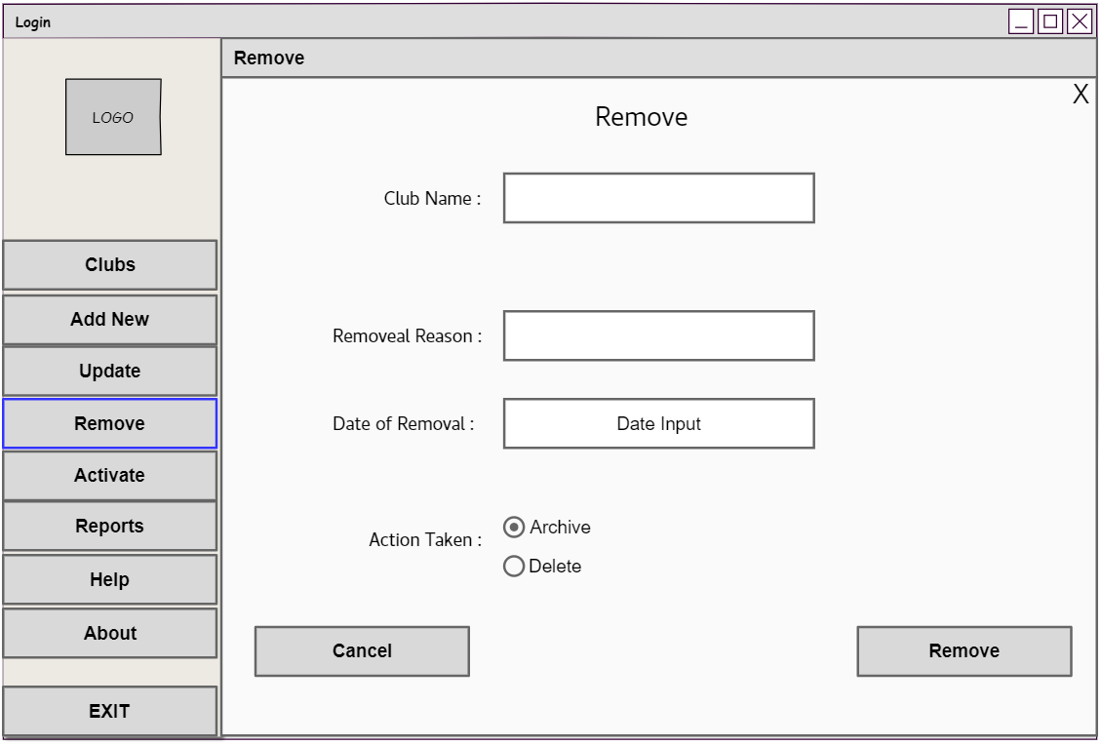
Button2

Control | Control name | Description
Form1 | SingIn | Webform responsible for singing in
Label1 | lblLogin | To act as header
Label2 | lblUsername | To label the related controls to the right
Label3 | lblPassword
Picturebox1 | Picturebox1 | To insert ad the logo picture
Picturebox1(Form1) | Picturebox1
Textbox1 | txtUsername | To accept text values form the user
Textbox2 | txtPassword
Button1 | btnHelp | Display a message box that contains contact mehtods
Button2 | btnAbout | Display a message box that contains an app description
Button3 | btnEXIT | Exit the application
Button1(Form1) | btnSignIn | Responsible for initializing code
Button2(Form1) | btnClear | Clear the text fields
Panel1 | panelSideMenu | Act as a side menu
button3
Label5

Control | Control name | Description
Form1 | SingIn | Webform responsible for singing in
Label1 | lblLogin | To act as header
Label2 | lblUsername | To label the related controls to the right
Label3 | lblPassword
Picturebox1 | Picturebox1 | To insert ad the logo picture
Picturebox1(Form1) | Picturebox1
Textbox1 | txtUsername | To accept text values form the user
Textbox2 | txtPassword
Button1 | btnHelp | Display a message box that contains contact mehtods
Button2 | btnAbout | Display a message box that contains an app description
Button3 | btnEXIT | Exit the application
Button1(Form1) | btnSignIn | Responsible for initializing code
Button2(Form1) | btnClear | Clear the text fields
Panel1 | panelSideMenu | Act as a side menu
button3
Radio1&2

Control | Control name | Description
Form1 | SingIn | Webform responsible for singing in
Label1 | lblLogin | To act as header
Label2 | lblUsername | To label the related controls to the right
Label3 | lblPassword
Picturebox1 | Picturebox1 | To insert ad the logo picture
Picturebox1(Form1) | Picturebox1
Textbox1 | txtUsername | To accept text values form the user
Textbox2 | txtPassword
Button1 | btnHelp | Display a message box that contains contact mehtods
Button2 | btnAbout | Display a message box that contains an app description
Button3 | btnEXIT | Exit the application
Button1(Form1) | btnSignIn | Responsible for initializing code
Button2(Form1) | btnClear | Clear the text fields
Panel1 | panelSideMenu | Act as a side menu
button3
Label3&4

Control | Control name | Description
Form1 | SingIn | Webform responsible for singing in
Label1 | lblLogin | To act as header
Label2 | lblUsername | To label the related controls to the right
Label3 | lblPassword
Picturebox1 | Picturebox1 | To insert ad the logo picture
Picturebox1(Form1) | Picturebox1
Textbox1 | txtUsername | To accept text values form the user
Textbox2 | txtPassword
Button1 | btnHelp | Display a message box that contains contact mehtods
Button2 | btnAbout | Display a message box that contains an app description
Button3 | btnEXIT | Exit the application
Button1(Form1) | btnSignIn | Responsible for initializing code
Button2(Form1) | btnClear | Clear the text fields
Panel1 | panelSideMenu | Act as a side menu
button3
Textbox2

Control | Control name | Description
Form1 | SingIn | Webform responsible for singing in
Label1 | lblLogin | To act as header
Label2 | lblUsername | To label the related controls to the right
Label3 | lblPassword
Picturebox1 | Picturebox1 | To insert ad the logo picture
Picturebox1(Form1) | Picturebox1
Textbox1 | txtUsername | To accept text values form the user
Textbox2 | txtPassword
Button1 | btnHelp | Display a message box that contains contact mehtods
Button2 | btnAbout | Display a message box that contains an app description
Button3 | btnEXIT | Exit the application
Button1(Form1) | btnSignIn | Responsible for initializing code
Button2(Form1) | btnClear | Clear the text fields
Panel1 | panelSideMenu | Act as a side menu
button3
Button2

Control | Control name | Description
Form1 | SingIn | Webform responsible for singing in
Label1 | lblLogin | To act as header
Label2 | lblUsername | To label the related controls to the right
Label3 | lblPassword
Picturebox1 | Picturebox1 | To insert ad the logo picture
Picturebox1(Form1) | Picturebox1
Textbox1 | txtUsername | To accept text values form the user
Textbox2 | txtPassword
Button1 | btnHelp | Display a message box that contains contact mehtods
Button2 | btnAbout | Display a message box that contains an app description
Button3 | btnEXIT | Exit the application
Button1(Form1) | btnSignIn | Responsible for initializing code
Button2(Form1) | btnClear | Clear the text fields
Panel1 | panelSideMenu | Act as a side menu
button3
Button2

Control | Control name | Description
Form1 | SingIn | Webform responsible for singing in
Label1 | lblLogin | To act as header
Label2 | lblUsername | To label the related controls to the right
Label3 | lblPassword
Picturebox1 | Picturebox1 | To insert ad the logo picture
Picturebox1(Form1) | Picturebox1
Textbox1 | txtUsername | To accept text values form the user
Textbox2 | txtPassword
Button1 | btnHelp | Display a message box that contains contact mehtods
Button2 | btnAbout | Display a message box that contains an app description
Button3 | btnEXIT | Exit the application
Button1(Form1) | btnSignIn | Responsible for initializing code
Button2(Form1) | btnClear | Clear the text fields
Panel1 | panelSideMenu | Act as a side menu
button3
Button1

Control | Control name | Description
Form1 | SingIn | Webform responsible for singing in
Label1 | lblLogin | To act as header
Label2 | lblUsername | To label the related controls to the right
Label3 | lblPassword
Picturebox1 | Picturebox1 | To insert ad the logo picture
Picturebox1(Form1) | Picturebox1
Textbox1 | txtUsername | To accept text values form the user
Textbox2 | txtPassword
Button1 | btnHelp | Display a message box that contains contact mehtods
Button2 | btnAbout | Display a message box that contains an app description
Button3 | btnEXIT | Exit the application
Button1(Form1) | btnSignIn | Responsible for initializing code
Button2(Form1) | btnClear | Clear the text fields
Panel1 | panelSideMenu | Act as a side menu
button3
Button2

Control | Control name | Description
Form1 | SingIn | Webform responsible for singing in
Label1 | lblLogin | To act as header
Label2 | lblUsername | To label the related controls to the right
Label3 | lblPassword
Picturebox1 | Picturebox1 | To insert ad the logo picture
Picturebox1(Form1) | Picturebox1
Textbox1 | txtUsername | To accept text values form the user
Textbox2 | txtPassword
Button1 | btnHelp | Display a message box that contains contact mehtods
Button2 | btnAbout | Display a message box that contains an app description
Button3 | btnEXIT | Exit the application
Button1(Form1) | btnSignIn | Responsible for initializing code
Button2(Form1) | btnClear | Clear the text fields
Panel1 | panelSideMenu | Act as a side menu
button3
DateTimePAicker

Control | Control name | Description
Form1 | SingIn | Webform responsible for singing in
Label1 | lblLogin | To act as header
Label2 | lblUsername | To label the related controls to the right
Label3 | lblPassword
Picturebox1 | Picturebox1 | To insert ad the logo picture
Picturebox1(Form1) | Picturebox1
Textbox1 | txtUsername | To accept text values form the user
Textbox2 | txtPassword
Button1 | btnHelp | Display a message box that contains contact mehtods
Button2 | btnAbout | Display a message box that contains an app description
Button3 | btnEXIT | Exit the application
Button1(Form1) | btnSignIn | Responsible for initializing code
Button2(Form1) | btnClear | Clear the text fields
Panel1 | panelSideMenu | Act as a side menu
button3
- Admin(Clubs-Activate):
Form6

Control | Control name | Description
Form1 | SingIn | Webform responsible for singing in
Label1 | lblLogin | To act as header
Label2 | lblUsername | To label the related controls to the right
Label3 | lblPassword
Picturebox1 | Picturebox1 | To insert ad the logo picture
Picturebox1(Form1) | Picturebox1
Textbox1 | txtUsername | To accept text values form the user
Textbox2 | txtPassword
Button1 | btnHelp | Display a message box that contains contact mehtods
Button2 | btnAbout | Display a message box that contains an app description
Button3 | btnEXIT | Exit the application
Button1(Form1) | btnSignIn | Responsible for initializing code
Button2(Form1) | btnClear | Clear the text fields
Panel1 | panelSideMenu | Act as a side menu
button3
Textbox1

Control | Control name | Description
Form1 | SingIn | Webform responsible for singing in
Label1 | lblLogin | To act as header
Label2 | lblUsername | To label the related controls to the right
Label3 | lblPassword
Picturebox1 | Picturebox1 | To insert ad the logo picture
Picturebox1(Form1) | Picturebox1
Textbox1 | txtUsername | To accept text values form the user
Textbox2 | txtPassword
Button1 | btnHelp | Display a message box that contains contact mehtods
Button2 | btnAbout | Display a message box that contains an app description
Button3 | btnEXIT | Exit the application
Button1(Form1) | btnSignIn | Responsible for initializing code
Button2(Form1) | btnClear | Clear the text fields
Panel1 | panelSideMenu | Act as a side menu
button3
Label1

Control | Control name | Description
Form1 | SingIn | Webform responsible for singing in
Label1 | lblLogin | To act as header
Label2 | lblUsername | To label the related controls to the right
Label3 | lblPassword
Picturebox1 | Picturebox1 | To insert ad the logo picture
Picturebox1(Form1) | Picturebox1
Textbox1 | txtUsername | To accept text values form the user
Textbox2 | txtPassword
Button1 | btnHelp | Display a message box that contains contact mehtods
Button2 | btnAbout | Display a message box that contains an app description
Button3 | btnEXIT | Exit the application
Button1(Form1) | btnSignIn | Responsible for initializing code
Button2(Form1) | btnClear | Clear the text fields
Panel1 | panelSideMenu | Act as a side menu
button3
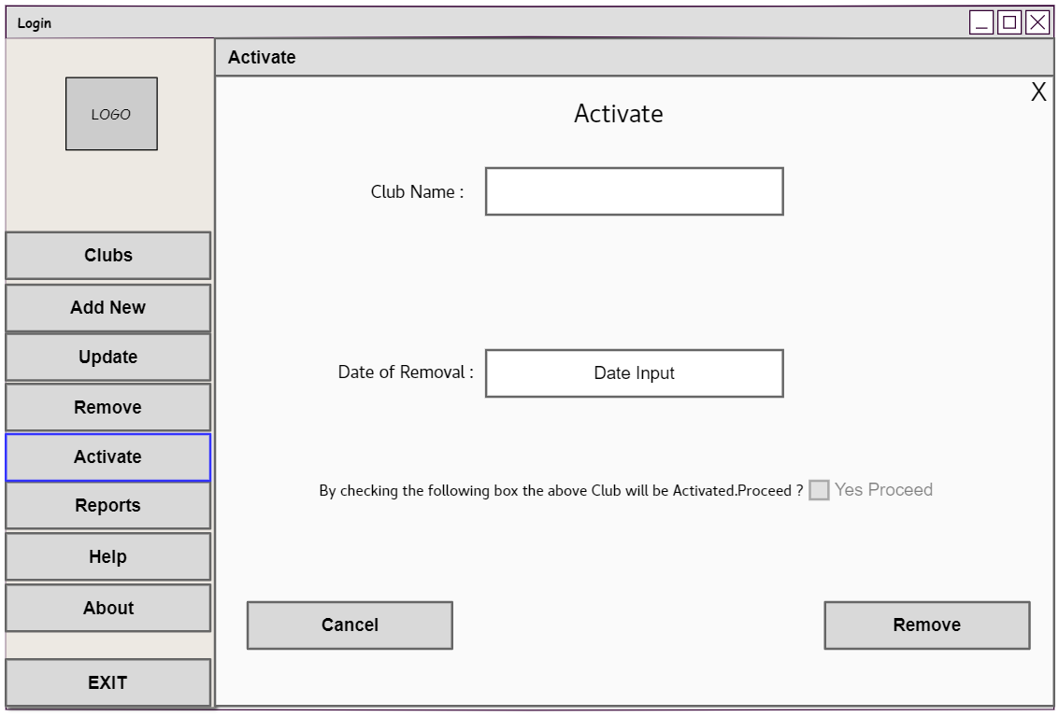
Checkbox1

Control | Control name | Description
Form1 | SingIn | Webform responsible for singing in
Label1 | lblLogin | To act as header
Label2 | lblUsername | To label the related controls to the right
Label3 | lblPassword
Picturebox1 | Picturebox1 | To insert ad the logo picture
Picturebox1(Form1) | Picturebox1
Textbox1 | txtUsername | To accept text values form the user
Textbox2 | txtPassword
Button1 | btnHelp | Display a message box that contains contact mehtods
Button2 | btnAbout | Display a message box that contains an app description
Button3 | btnEXIT | Exit the application
Button1(Form1) | btnSignIn | Responsible for initializing code
Button2(Form1) | btnClear | Clear the text fields
Panel1 | panelSideMenu | Act as a side menu
button3
Label2

Control | Control name | Description
Form1 | SingIn | Webform responsible for singing in
Label1 | lblLogin | To act as header
Label2 | lblUsername | To label the related controls to the right
Label3 | lblPassword
Picturebox1 | Picturebox1 | To insert ad the logo picture
Picturebox1(Form1) | Picturebox1
Textbox1 | txtUsername | To accept text values form the user
Textbox2 | txtPassword
Button1 | btnHelp | Display a message box that contains contact mehtods
Button2 | btnAbout | Display a message box that contains an app description
Button3 | btnEXIT | Exit the application
Button1(Form1) | btnSignIn | Responsible for initializing code
Button2(Form1) | btnClear | Clear the text fields
Panel1 | panelSideMenu | Act as a side menu
button3
Label3

Control | Control name | Description
Form1 | SingIn | Webform responsible for singing in
Label1 | lblLogin | To act as header
Label2 | lblUsername | To label the related controls to the right
Label3 | lblPassword
Picturebox1 | Picturebox1 | To insert ad the logo picture
Picturebox1(Form1) | Picturebox1
Textbox1 | txtUsername | To accept text values form the user
Textbox2 | txtPassword
Button1 | btnHelp | Display a message box that contains contact mehtods
Button2 | btnAbout | Display a message box that contains an app description
Button3 | btnEXIT | Exit the application
Button1(Form1) | btnSignIn | Responsible for initializing code
Button2(Form1) | btnClear | Clear the text fields
Panel1 | panelSideMenu | Act as a side menu
button3
DateTimePicker1

Control | Control name | Description
Form1 | SingIn | Webform responsible for singing in
Label1 | lblLogin | To act as header
Label2 | lblUsername | To label the related controls to the right
Label3 | lblPassword
Picturebox1 | Picturebox1 | To insert ad the logo picture
Picturebox1(Form1) | Picturebox1
Textbox1 | txtUsername | To accept text values form the user
Textbox2 | txtPassword
Button1 | btnHelp | Display a message box that contains contact mehtods
Button2 | btnAbout | Display a message box that contains an app description
Button3 | btnEXIT | Exit the application
Button1(Form1) | btnSignIn | Responsible for initializing code
Button2(Form1) | btnClear | Clear the text fields
Panel1 | panelSideMenu | Act as a side menu
button3
Button1

Control | Control name | Description
Form1 | SingIn | Webform responsible for singing in
Label1 | lblLogin | To act as header
Label2 | lblUsername | To label the related controls to the right
Label3 | lblPassword
Picturebox1 | Picturebox1 | To insert ad the logo picture
Picturebox1(Form1) | Picturebox1
Textbox1 | txtUsername | To accept text values form the user
Textbox2 | txtPassword
Button1 | btnHelp | Display a message box that contains contact mehtods
Button2 | btnAbout | Display a message box that contains an app description
Button3 | btnEXIT | Exit the application
Button1(Form1) | btnSignIn | Responsible for initializing code
Button2(Form1) | btnClear | Clear the text fields
Panel1 | panelSideMenu | Act as a side menu
button3
Button1

Control | Control name | Description
Form1 | SingIn | Webform responsible for singing in
Label1 | lblLogin | To act as header
Label2 | lblUsername | To label the related controls to the right
Label3 | lblPassword
Picturebox1 | Picturebox1 | To insert ad the logo picture
Picturebox1(Form1) | Picturebox1
Textbox1 | txtUsername | To accept text values form the user
Textbox2 | txtPassword
Button1 | btnHelp | Display a message box that contains contact mehtods
Button2 | btnAbout | Display a message box that contains an app description
Button3 | btnEXIT | Exit the application
Button1(Form1) | btnSignIn | Responsible for initializing code
Button2(Form1) | btnClear | Clear the text fields
Panel1 | panelSideMenu | Act as a side menu
button3
Label4

Control | Control name | Description
Form1 | SingIn | Webform responsible for singing in
Label1 | lblLogin | To act as header
Label2 | lblUsername | To label the related controls to the right
Label3 | lblPassword
Picturebox1 | Picturebox1 | To insert ad the logo picture
Picturebox1(Form1) | Picturebox1
Textbox1 | txtUsername | To accept text values form the user
Textbox2 | txtPassword
Button1 | btnHelp | Display a message box that contains contact mehtods
Button2 | btnAbout | Display a message box that contains an app description
Button3 | btnEXIT | Exit the application
Button1(Form1) | btnSignIn | Responsible for initializing code
Button2(Form1) | btnClear | Clear the text fields
Panel1 | panelSideMenu | Act as a side menu
button3

Admin View(Clubs-Remove):
Control | Control name | description
Form5 | Remove | Responsible for removing specified clubs
Label1 | lblTitle | Act as a header
Label2 | Label2 | To label the related controls to the right
Label3 | Label3 | To label the related controls to the right
Label4 | Label4 | To label the related controls to the right
Label5 | Label5 | To label the related controls to the right
Textbox1 | txtClubName | Accept club name
Textbox2 | txtRemoveReason | Accept the reason of removal
DateTimePicker | DateTimePicker | Accept the date of removal
Radiobutton 1&2 | Radiobutton 1&2 | Specify the action desired to be taken
Button1 | btnRemove | Delete or archive the info of the specified club
Button2 | btnCancel | Clear the text values from the text boxes

Admin View(Clubs-Activate):
Control | Control name | Description
Form5 | Activate | Responsible for activating archived clubs
Labe1 | lbltitle | Act as a header
Label2 | Label2 | To label the related controls to the right
Label3 | Label3 | To label the related controls to the right
Label4 | Label4 | To label the related controls to the right
Textbox1 | TxtClubName | Accept the name of the club
DateTimePicker | DateTimePicker | Accept the date of activation
Chekbox1 | chkConfirm | Confirm the request of activation
Button1 | btnActivate | Activate the desired club
Button2 | btnCancel | Clear the text values from the text boxes

Label2

Control | Control name | Description
Form1 | SingIn | Webform responsible for singing in
Label1 | lblLogin | To act as header
Label2 | lblUsername | To label the related controls to the right
Label3 | lblPassword
Picturebox1 | Picturebox1 | To insert ad the logo picture
Picturebox1(Form1) | Picturebox1
Textbox1 | txtUsername | To accept text values form the user
Textbox2 | txtPassword
Button1 | btnHelp | Display a message box that contains contact mehtods
Button2 | btnAbout | Display a message box that contains an app description
Button3 | btnEXIT | Exit the application
Button1(Form1) | btnSignIn | Responsible for initializing code
Button2(Form1) | btnClear | Clear the text fields
Panel1 | panelSideMenu | Act as a side menu
button3
Label1

Control | Control name | Description
Form1 | SingIn | Webform responsible for singing in
Label1 | lblLogin | To act as header
Label2 | lblUsername | To label the related controls to the right
Label3 | lblPassword
Picturebox1 | Picturebox1 | To insert ad the logo picture
Picturebox1(Form1) | Picturebox1
Textbox1 | txtUsername | To accept text values form the user
Textbox2 | txtPassword
Button1 | btnHelp | Display a message box that contains contact mehtods
Button2 | btnAbout | Display a message box that contains an app description
Button3 | btnEXIT | Exit the application
Button1(Form1) | btnSignIn | Responsible for initializing code
Button2(Form1) | btnClear | Clear the text fields
Panel1 | panelSideMenu | Act as a side menu
button3
Admin-View(Reports-List Report):
Form7

Control | Control name | Description
Form1 | SingIn | Webform responsible for singing in
Label1 | lblLogin | To act as header
Label2 | lblUsername | To label the related controls to the right
Label3 | lblPassword
Picturebox1 | Picturebox1 | To insert ad the logo picture
Picturebox1(Form1) | Picturebox1
Textbox1 | txtUsername | To accept text values form the user
Textbox2 | txtPassword
Button1 | btnHelp | Display a message box that contains contact mehtods
Button2 | btnAbout | Display a message box that contains an app description
Button3 | btnEXIT | Exit the application
Button1(Form1) | btnSignIn | Responsible for initializing code
Button2(Form1) | btnClear | Clear the text fields
Panel1 | panelSideMenu | Act as a side menu
button3

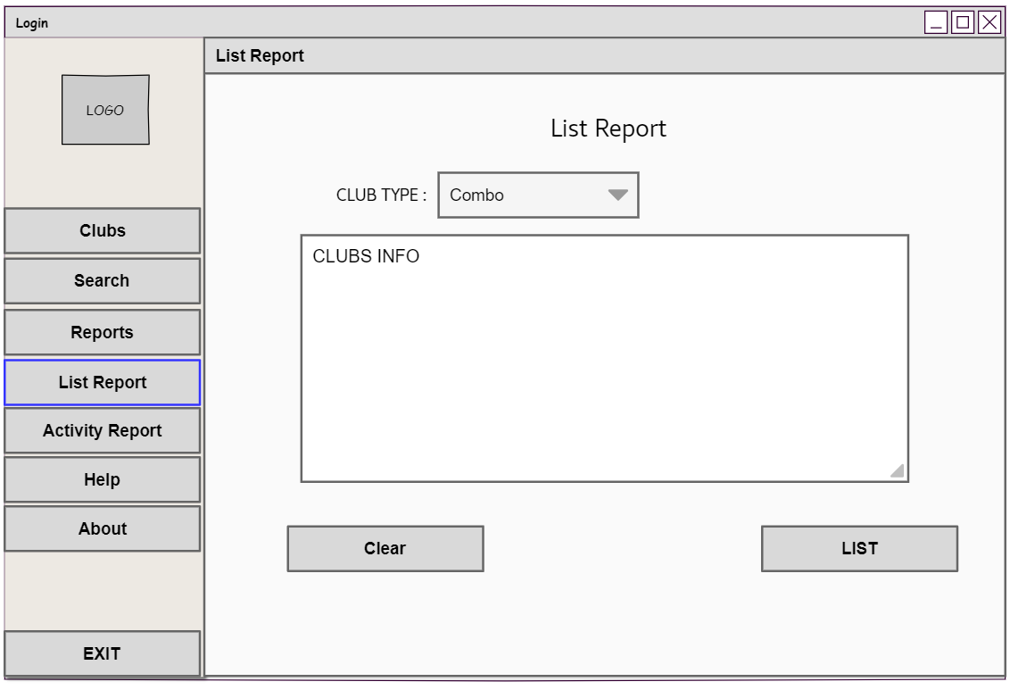
Combobox1

Control | Control name | Description
Form1 | SingIn | Webform responsible for singing in
Label1 | lblLogin | To act as header
Label2 | lblUsername | To label the related controls to the right
Label3 | lblPassword
Picturebox1 | Picturebox1 | To insert ad the logo picture
Picturebox1(Form1) | Picturebox1
Textbox1 | txtUsername | To accept text values form the user
Textbox2 | txtPassword
Button1 | btnHelp | Display a message box that contains contact mehtods
Button2 | btnAbout | Display a message box that contains an app description
Button3 | btnEXIT | Exit the application
Button1(Form1) | btnSignIn | Responsible for initializing code
Button2(Form1) | btnClear | Clear the text fields
Panel1 | panelSideMenu | Act as a side menu
button3
ListBox1

Control | Control name | Description
Form1 | SingIn | Webform responsible for singing in
Label1 | lblLogin | To act as header
Label2 | lblUsername | To label the related controls to the right
Label3 | lblPassword
Picturebox1 | Picturebox1 | To insert ad the logo picture
Picturebox1(Form1) | Picturebox1
Textbox1 | txtUsername | To accept text values form the user
Textbox2 | txtPassword
Button1 | btnHelp | Display a message box that contains contact mehtods
Button2 | btnAbout | Display a message box that contains an app description
Button3 | btnEXIT | Exit the application
Button1(Form1) | btnSignIn | Responsible for initializing code
Button2(Form1) | btnClear | Clear the text fields
Panel1 | panelSideMenu | Act as a side menu
button3
Button1

Control | Control name | Description
Form1 | SingIn | Webform responsible for singing in
Label1 | lblLogin | To act as header
Label2 | lblUsername | To label the related controls to the right
Label3 | lblPassword
Picturebox1 | Picturebox1 | To insert ad the logo picture
Picturebox1(Form1) | Picturebox1
Textbox1 | txtUsername | To accept text values form the user
Textbox2 | txtPassword
Button1 | btnHelp | Display a message box that contains contact mehtods
Button2 | btnAbout | Display a message box that contains an app description
Button3 | btnEXIT | Exit the application
Button1(Form1) | btnSignIn | Responsible for initializing code
Button2(Form1) | btnClear | Clear the text fields
Panel1 | panelSideMenu | Act as a side menu
button3
Button2

Control | Control name | Description
Form1 | SingIn | Webform responsible for singing in
Label1 | lblLogin | To act as header
Label2 | lblUsername | To label the related controls to the right
Label3 | lblPassword
Picturebox1 | Picturebox1 | To insert ad the logo picture
Picturebox1(Form1) | Picturebox1
Textbox1 | txtUsername | To accept text values form the user
Textbox2 | txtPassword
Button1 | btnHelp | Display a message box that contains contact mehtods
Button2 | btnAbout | Display a message box that contains an app description
Button3 | btnEXIT | Exit the application
Button1(Form1) | btnSignIn | Responsible for initializing code
Button2(Form1) | btnClear | Clear the text fields
Panel1 | panelSideMenu | Act as a side menu
button3

Admin-View(Reports-List Report):
Control | Control Name | Description
Form7 | ListReport | Responsible for displaying the Club list Report
Label1 | lblTitle | Act as a header
Label2 | Label2 | To label the related controls to the right
Combobox1 | cboClubType | Prompt the user to choose the club type
listBox1 | listClubInfo | Display the club info to the user
Button1 | BtnList | Activate the code the list the info to the user
Button2 | btnClear | Clear the text values form the text boxes

Admin-View(Reports-Activity Report):
Label1

Control | Control name | Description
Form1 | SingIn | Webform responsible for singing in
Label1 | lblLogin | To act as header
Label2 | lblUsername | To label the related controls to the right
Label3 | lblPassword
Picturebox1 | Picturebox1 | To insert ad the logo picture
Picturebox1(Form1) | Picturebox1
Textbox1 | txtUsername | To accept text values form the user
Textbox2 | txtPassword
Button1 | btnHelp | Display a message box that contains contact mehtods
Button2 | btnAbout | Display a message box that contains an app description
Button3 | btnEXIT | Exit the application
Button1(Form1) | btnSignIn | Responsible for initializing code
Button2(Form1) | btnClear | Clear the text fields
Panel1 | panelSideMenu | Act as a side menu
button3
Form8

Control | Control name | Description
Form1 | SingIn | Webform responsible for singing in
Label1 | lblLogin | To act as header
Label2 | lblUsername | To label the related controls to the right
Label3 | lblPassword
Picturebox1 | Picturebox1 | To insert ad the logo picture
Picturebox1(Form1) | Picturebox1
Textbox1 | txtUsername | To accept text values form the user
Textbox2 | txtPassword
Button1 | btnHelp | Display a message box that contains contact mehtods
Button2 | btnAbout | Display a message box that contains an app description
Button3 | btnEXIT | Exit the application
Button1(Form1) | btnSignIn | Responsible for initializing code
Button2(Form1) | btnClear | Clear the text fields
Panel1 | panelSideMenu | Act as a side menu
button3

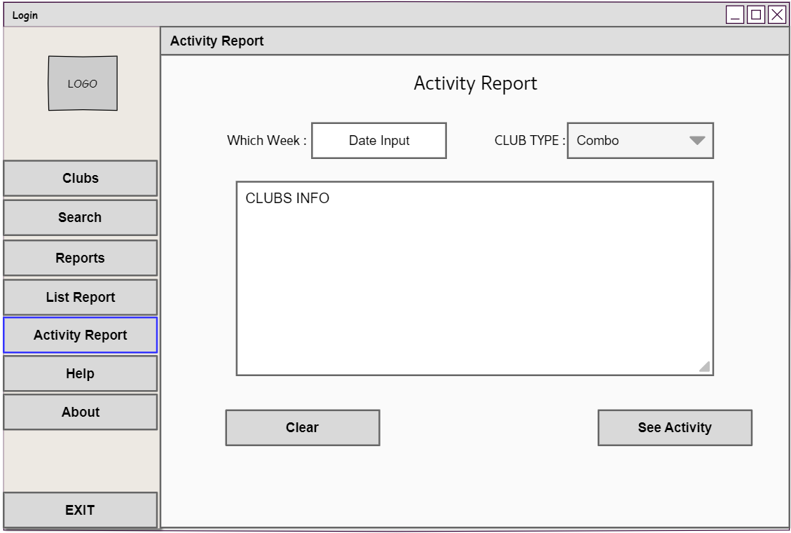
Label3

Control | Control name | Description
Form1 | SingIn | Webform responsible for singing in
Label1 | lblLogin | To act as header
Label2 | lblUsername | To label the related controls to the right
Label3 | lblPassword
Picturebox1 | Picturebox1 | To insert ad the logo picture
Picturebox1(Form1) | Picturebox1
Textbox1 | txtUsername | To accept text values form the user
Textbox2 | txtPassword
Button1 | btnHelp | Display a message box that contains contact mehtods
Button2 | btnAbout | Display a message box that contains an app description
Button3 | btnEXIT | Exit the application
Button1(Form1) | btnSignIn | Responsible for initializing code
Button2(Form1) | btnClear | Clear the text fields
Panel1 | panelSideMenu | Act as a side menu
button3
ComboBox1

Control | Control name | Description
Form1 | SingIn | Webform responsible for singing in
Label1 | lblLogin | To act as header
Label2 | lblUsername | To label the related controls to the right
Label3 | lblPassword
Picturebox1 | Picturebox1 | To insert ad the logo picture
Picturebox1(Form1) | Picturebox1
Textbox1 | txtUsername | To accept text values form the user
Textbox2 | txtPassword
Button1 | btnHelp | Display a message box that contains contact mehtods
Button2 | btnAbout | Display a message box that contains an app description
Button3 | btnEXIT | Exit the application
Button1(Form1) | btnSignIn | Responsible for initializing code
Button2(Form1) | btnClear | Clear the text fields
Panel1 | panelSideMenu | Act as a side menu
button3
ListBox1

Control | Control name | Description
Form1 | SingIn | Webform responsible for singing in
Label1 | lblLogin | To act as header
Label2 | lblUsername | To label the related controls to the right
Label3 | lblPassword
Picturebox1 | Picturebox1 | To insert ad the logo picture
Picturebox1(Form1) | Picturebox1
Textbox1 | txtUsername | To accept text values form the user
Textbox2 | txtPassword
Button1 | btnHelp | Display a message box that contains contact mehtods
Button2 | btnAbout | Display a message box that contains an app description
Button3 | btnEXIT | Exit the application
Button1(Form1) | btnSignIn | Responsible for initializing code
Button2(Form1) | btnClear | Clear the text fields
Panel1 | panelSideMenu | Act as a side menu
button3
Button1

Control | Control name | Description
Form1 | SingIn | Webform responsible for singing in
Label1 | lblLogin | To act as header
Label2 | lblUsername | To label the related controls to the right
Label3 | lblPassword
Picturebox1 | Picturebox1 | To insert ad the logo picture
Picturebox1(Form1) | Picturebox1
Textbox1 | txtUsername | To accept text values form the user
Textbox2 | txtPassword
Button1 | btnHelp | Display a message box that contains contact mehtods
Button2 | btnAbout | Display a message box that contains an app description
Button3 | btnEXIT | Exit the application
Button1(Form1) | btnSignIn | Responsible for initializing code
Button2(Form1) | btnClear | Clear the text fields
Panel1 | panelSideMenu | Act as a side menu
button3
Label2

Control | Control name | Description
Form1 | SingIn | Webform responsible for singing in
Label1 | lblLogin | To act as header
Label2 | lblUsername | To label the related controls to the right
Label3 | lblPassword
Picturebox1 | Picturebox1 | To insert ad the logo picture
Picturebox1(Form1) | Picturebox1
Textbox1 | txtUsername | To accept text values form the user
Textbox2 | txtPassword
Button1 | btnHelp | Display a message box that contains contact mehtods
Button2 | btnAbout | Display a message box that contains an app description
Button3 | btnEXIT | Exit the application
Button1(Form1) | btnSignIn | Responsible for initializing code
Button2(Form1) | btnClear | Clear the text fields
Panel1 | panelSideMenu | Act as a side menu
button3
Button2

Control | Control name | Description
Form1 | SingIn | Webform responsible for singing in
Label1 | lblLogin | To act as header
Label2 | lblUsername | To label the related controls to the right
Label3 | lblPassword
Picturebox1 | Picturebox1 | To insert ad the logo picture
Picturebox1(Form1) | Picturebox1
Textbox1 | txtUsername | To accept text values form the user
Textbox2 | txtPassword
Button1 | btnHelp | Display a message box that contains contact mehtods
Button2 | btnAbout | Display a message box that contains an app description
Button3 | btnEXIT | Exit the application
Button1(Form1) | btnSignIn | Responsible for initializing code
Button2(Form1) | btnClear | Clear the text fields
Panel1 | panelSideMenu | Act as a side menu
button3

Admin-View(Reports-Activity Report):

Control | Control Name | Description
Form8 | ActivityReport | Responsible for displaying the activity of a specific club for a specific week
Label1 | lblTitle | Act as a header
Label2 | Label2 | To label the related controls to the right
Label3 | Label3 | To label the related controls to the right
ComboBox1 | cboClubType | Prompt the user to specify the club type
listBox1 | listInfo | Display the info to the user
Button1 | btnSeeActivity | Activate the code to display the info
Button2 | btnClear | Clear the text Values of the hole form

Admin-View(Search):
Form9

Control | Control name | Description
Form1 | SingIn | Webform responsible for singing in
Label1 | lblLogin | To act as header
Label2 | lblUsername | To label the related controls to the right
Label3 | lblPassword
Picturebox1 | Picturebox1 | To insert ad the logo picture
Picturebox1(Form1) | Picturebox1
Textbox1 | txtUsername | To accept text values form the user
Textbox2 | txtPassword
Button1 | btnHelp | Display a message box that contains contact mehtods
Button2 | btnAbout | Display a message box that contains an app description
Button3 | btnEXIT | Exit the application
Button1(Form1) | btnSignIn | Responsible for initializing code
Button2(Form1) | btnClear | Clear the text fields
Panel1 | panelSideMenu | Act as a side menu
button3
Label2

Control | Control name | Description
Form1 | SingIn | Webform responsible for singing in
Label1 | lblLogin | To act as header
Label2 | lblUsername | To label the related controls to the right
Label3 | lblPassword
Picturebox1 | Picturebox1 | To insert ad the logo picture
Picturebox1(Form1) | Picturebox1
Textbox1 | txtUsername | To accept text values form the user
Textbox2 | txtPassword
Button1 | btnHelp | Display a message box that contains contact mehtods
Button2 | btnAbout | Display a message box that contains an app description
Button3 | btnEXIT | Exit the application
Button1(Form1) | btnSignIn | Responsible for initializing code
Button2(Form1) | btnClear | Clear the text fields
Panel1 | panelSideMenu | Act as a side menu
button3
Label1

Control | Control name | Description
Form1 | SingIn | Webform responsible for singing in
Label1 | lblLogin | To act as header
Label2 | lblUsername | To label the related controls to the right
Label3 | lblPassword
Picturebox1 | Picturebox1 | To insert ad the logo picture
Picturebox1(Form1) | Picturebox1
Textbox1 | txtUsername | To accept text values form the user
Textbox2 | txtPassword
Button1 | btnHelp | Display a message box that contains contact mehtods
Button2 | btnAbout | Display a message box that contains an app description
Button3 | btnEXIT | Exit the application
Button1(Form1) | btnSignIn | Responsible for initializing code
Button2(Form1) | btnClear | Clear the text fields
Panel1 | panelSideMenu | Act as a side menu
button3

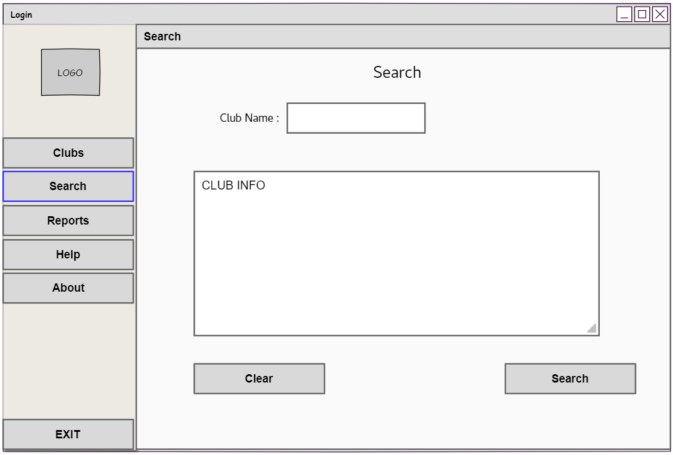
ListBox1

Control | Control name | Description
Form1 | SingIn | Webform responsible for singing in
Label1 | lblLogin | To act as header
Label2 | lblUsername | To label the related controls to the right
Label3 | lblPassword
Picturebox1 | Picturebox1 | To insert ad the logo picture
Picturebox1(Form1) | Picturebox1
Textbox1 | txtUsername | To accept text values form the user
Textbox2 | txtPassword
Button1 | btnHelp | Display a message box that contains contact mehtods
Button2 | btnAbout | Display a message box that contains an app description
Button3 | btnEXIT | Exit the application
Button1(Form1) | btnSignIn | Responsible for initializing code
Button2(Form1) | btnClear | Clear the text fields
Panel1 | panelSideMenu | Act as a side menu
button3
TextBox1

Control | Control name | Description
Form1 | SingIn | Webform responsible for singing in
Label1 | lblLogin | To act as header
Label2 | lblUsername | To label the related controls to the right
Label3 | lblPassword
Picturebox1 | Picturebox1 | To insert ad the logo picture
Picturebox1(Form1) | Picturebox1
Textbox1 | txtUsername | To accept text values form the user
Textbox2 | txtPassword
Button1 | btnHelp | Display a message box that contains contact mehtods
Button2 | btnAbout | Display a message box that contains an app description
Button3 | btnEXIT | Exit the application
Button1(Form1) | btnSignIn | Responsible for initializing code
Button2(Form1) | btnClear | Clear the text fields
Panel1 | panelSideMenu | Act as a side menu
button3
Button1

Control | Control name | Description
Form1 | SingIn | Webform responsible for singing in
Label1 | lblLogin | To act as header
Label2 | lblUsername | To label the related controls to the right
Label3 | lblPassword
Picturebox1 | Picturebox1 | To insert ad the logo picture
Picturebox1(Form1) | Picturebox1
Textbox1 | txtUsername | To accept text values form the user
Textbox2 | txtPassword
Button1 | btnHelp | Display a message box that contains contact mehtods
Button2 | btnAbout | Display a message box that contains an app description
Button3 | btnEXIT | Exit the application
Button1(Form1) | btnSignIn | Responsible for initializing code
Button2(Form1) | btnClear | Clear the text fields
Panel1 | panelSideMenu | Act as a side menu
button3

Button2

Control | Control name | Description
Form1 | SingIn | Webform responsible for singing in
Label1 | lblLogin | To act as header
Label2 | lblUsername | To label the related controls to the right
Label3 | lblPassword
Picturebox1 | Picturebox1 | To insert ad the logo picture
Picturebox1(Form1) | Picturebox1
Textbox1 | txtUsername | To accept text values form the user
Textbox2 | txtPassword
Button1 | btnHelp | Display a message box that contains contact mehtods
Button2 | btnAbout | Display a message box that contains an app description
Button3 | btnEXIT | Exit the application
Button1(Form1) | btnSignIn | Responsible for initializing code
Button2(Form1) | btnClear | Clear the text fields
Panel1 | panelSideMenu | Act as a side menu
button3

Admin-View(Search):
Control | Control Name | Description
Form9 | Search | Responsible for searching of a specific club info
Label1 | lblTitle | Act as a header
Label2 | Label2 | Label the related controls to the right
TextBox1 | txtClubName | Accept the club name from the user
ListBox1 | listInfo | Display the club info to the user
Button1 | btnSearch | Activate the code that display club info
Button2 | btnClear | Clear the text values form the whole form

Club Representative View:(Omar Sharif Tp056801)
Form 10
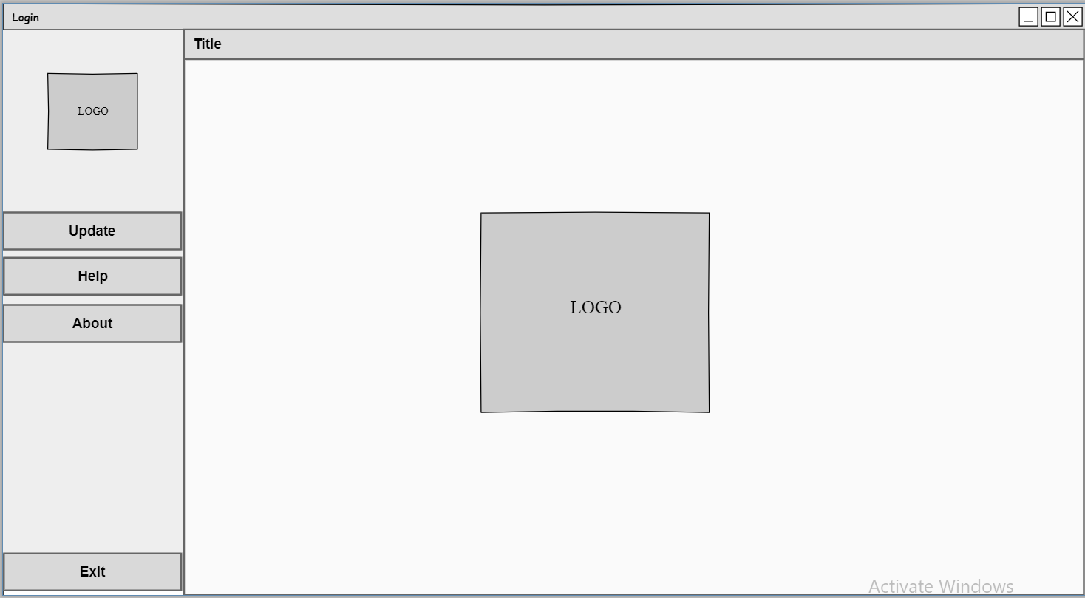
Button 13

Control | Control Name | Description
Form 10 | Logo | Displays Logo after signing in
Button 13 | btnUpdate | For updating the club’s description and weekly updates

Update [View]:
Form 11
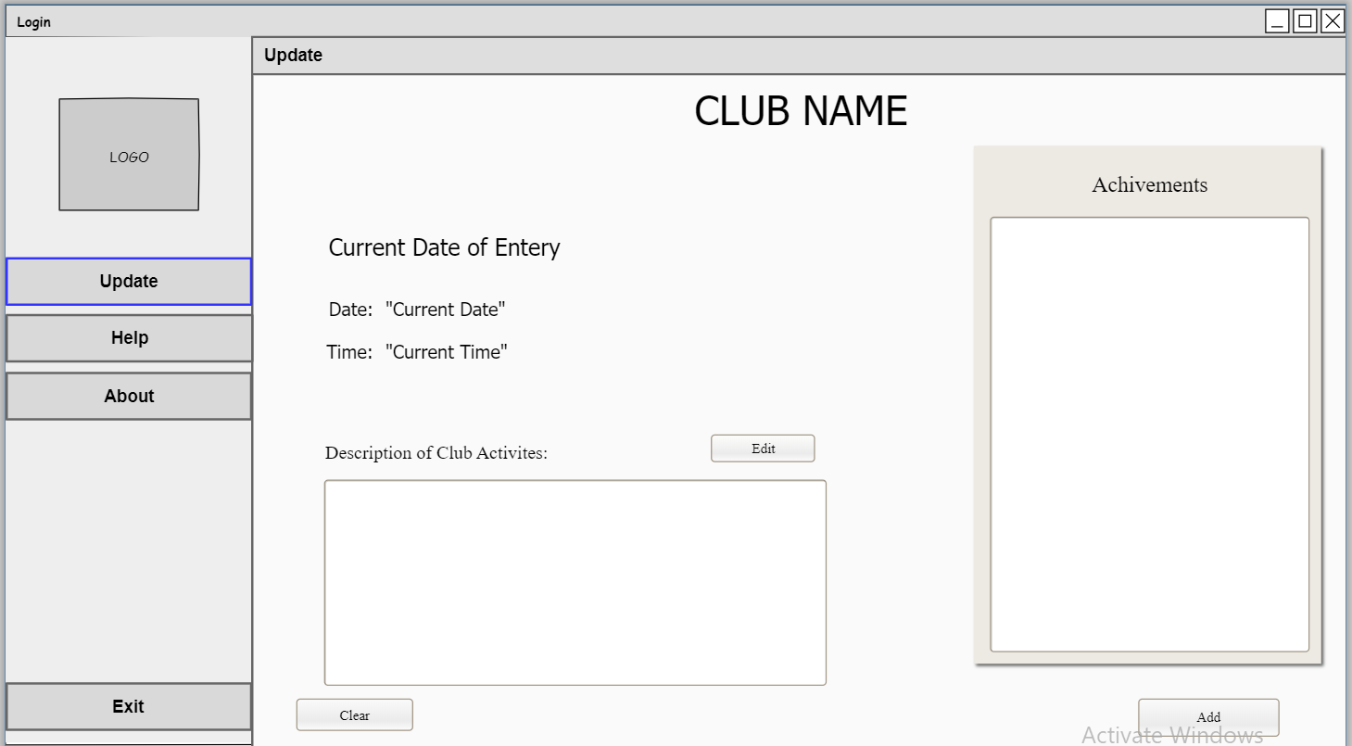
Label 1
Label 2
Label 3
Label 4
Label 5
Label 6
Label 7
Label 8
Text-Box 2
Button 1
Text-Box 1
Button 2
Button 3

Control | Control name | Description
Form 11 | Update | Responsible for the weekly updates of club description activities and achievements
Label 1 | lblTitle | Act as a header
Label 2 | Label2 | Labels to the related controls under it
Label 3 | Label 3 | Labels to the related control on the right side
Label 4 | Label 4 | Labels to the realted control on the right side
Label 5 | lblDate | Adds the current date
Label 6 | lblTime | Adds the current time
Label 7 | Label 7 | Labels to the related control under it
Label | Label 8 | Labels to the related control under it
Text-Box 1 | txtDescription | Accepts the club description
Text-Box 2 | txtAchivements | Accepts the clubs new achievements
Button 1 | btnClear | Clear the text value from the whole form
Button 2 | btnEdit | Edits the club description
Button 3 | btnAdd | Adds the club new updates of description and achievements to the connected database

Student View:
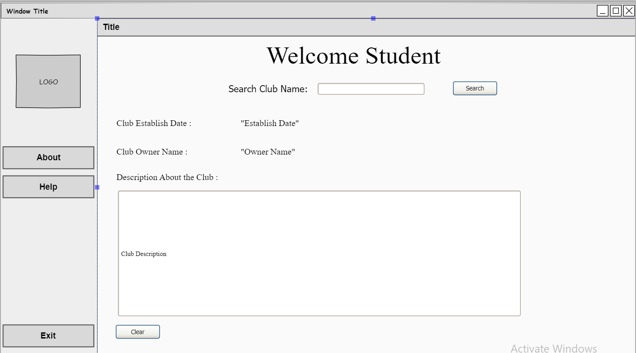
Button 2
Form 12
Label 1
Button 1
Label 2
Textbox 1
Label 3
Label 4
Label 5
Label 6
Label 7
Listbox 1

Control | Control Name | Description
Form 12 | Search | For searching club info
Label 1 | lblTitle | Act as a header
Label 2 | Label 2 | Labels to the related control on the right side
Label 3 | Label 3 | Labels to the related control on the right side
Label 4 | Label 4 | Labels to the related control on the right side
Label 5 | Label 5 | Labels to the related control on the right side
Label 6 | lblDate | To display the club establish date
Label 7 | lblName | To display the club owner name
Button 1 | btnSearch | To search for the club name
Text Box 1 | txtSearch | Used to enter club name
List box 1 | listDescripiton | To display all the club description
Button 2 | btnClear | To clear the text value from the whole form

